UPPWISE INDIA

www.uppwise.com



**Quaterly Development Planning**

**Q1-2024**

**Feature: Financial Widget Modification**

**Feature Title:**

Financial Widget Modifications

**Priority:**

Medium

**Submitted By:**

SPM

**Target Users:**

Standard SPM User

**Feature Description:**

In this feature, we aim to integrate multiple functionalities similar to those available in the POX. Our primary objective is to enhance user flexibility by introducing the ability to customize column labels directly from the settings area. This customization empowers users to personalize column names within the widget based on their preferences.

Furthermore, we will streamline the integration of phasing types, grouping options, and comment functionalities seamlessly within the widget interface.

**Acceptance Criteria:**

**Custom Column Naming:**

Introducing a multi-tab format within the cost tab, where users can easily customize column labels directly from the initiative custom field. One tab manages custom fields, while another tab manages standard fields. This user-friendly interface allows for seamless modification of column names based on individual preferences. Additionally, users have the option to add customized graphical name indicators for custom names they want to display in the grid, User can hover on those visual indicator over the widget and can able to see the customized names.

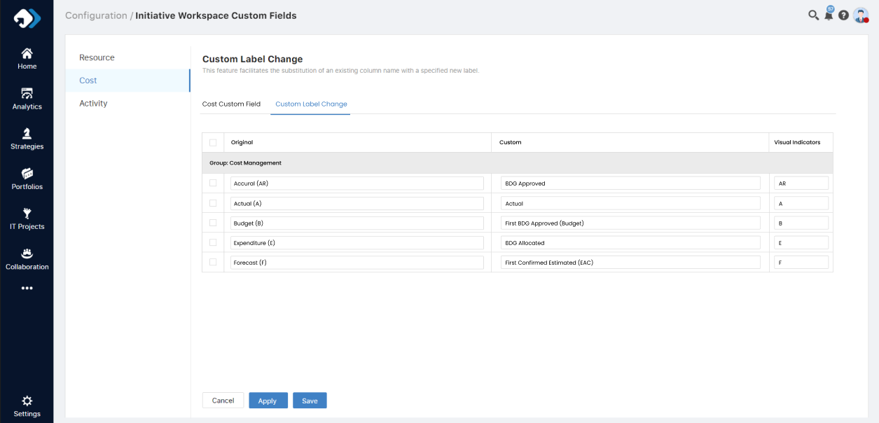

**Widget Field Enhancement**

* BDG Estimated - New Field
* BDG Estimated Confirmed (EAC) - Forecast
* First BDG Approved – Budget
* BDG Approved – Accural
* BDG Allocated – Expenditure
* Actual – Same as earlier
* BAU Generated – New Field

The widget now includes both Accrual and Expenditure as total values, presented as new columns too.

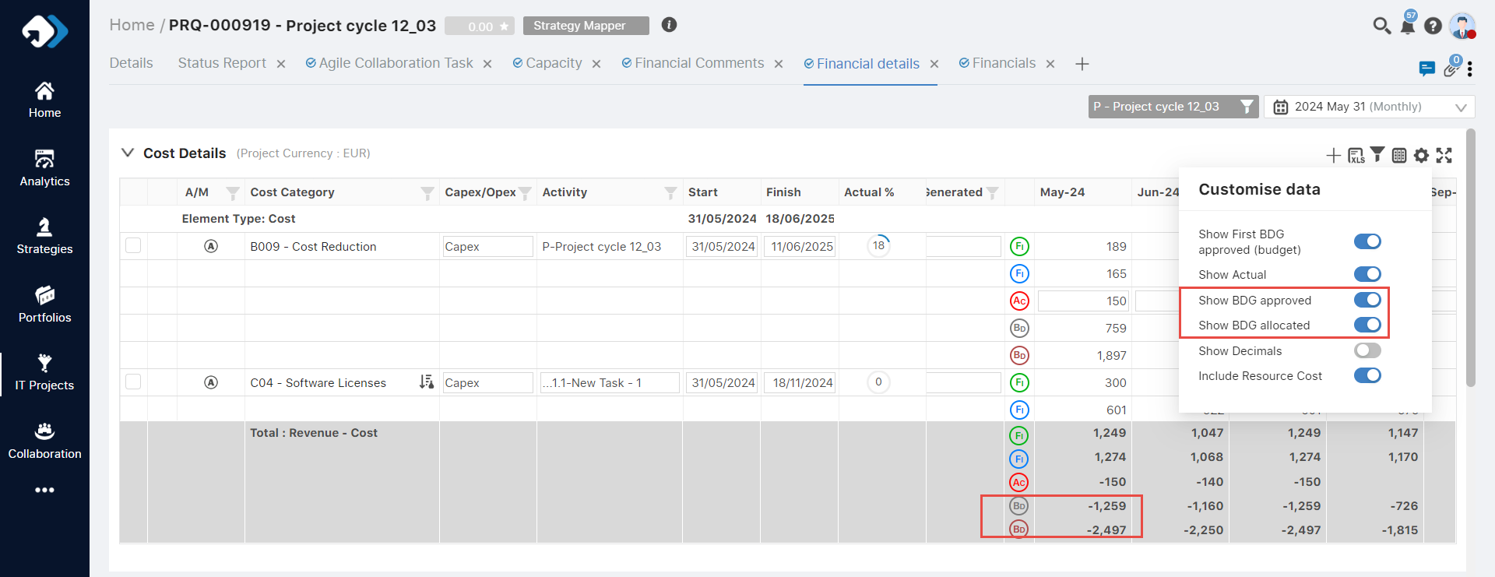

**Functionality Alignment which we have in the SPM currently:**

* **Phasing Type:** We have a single widget for the cost details and phasing all together in the same widget in the application.
* **Group By:** As we all know, in the SPM we have standard functionality for group by. Users can select and create grouping on required field in the widget.

**Investments & BAU Comments:**

We have created a widget with specific fields, separately for POX. Users can choose the comment type and select a custom date to input their comment. Additionally, we have a corresponding data source for analytics.

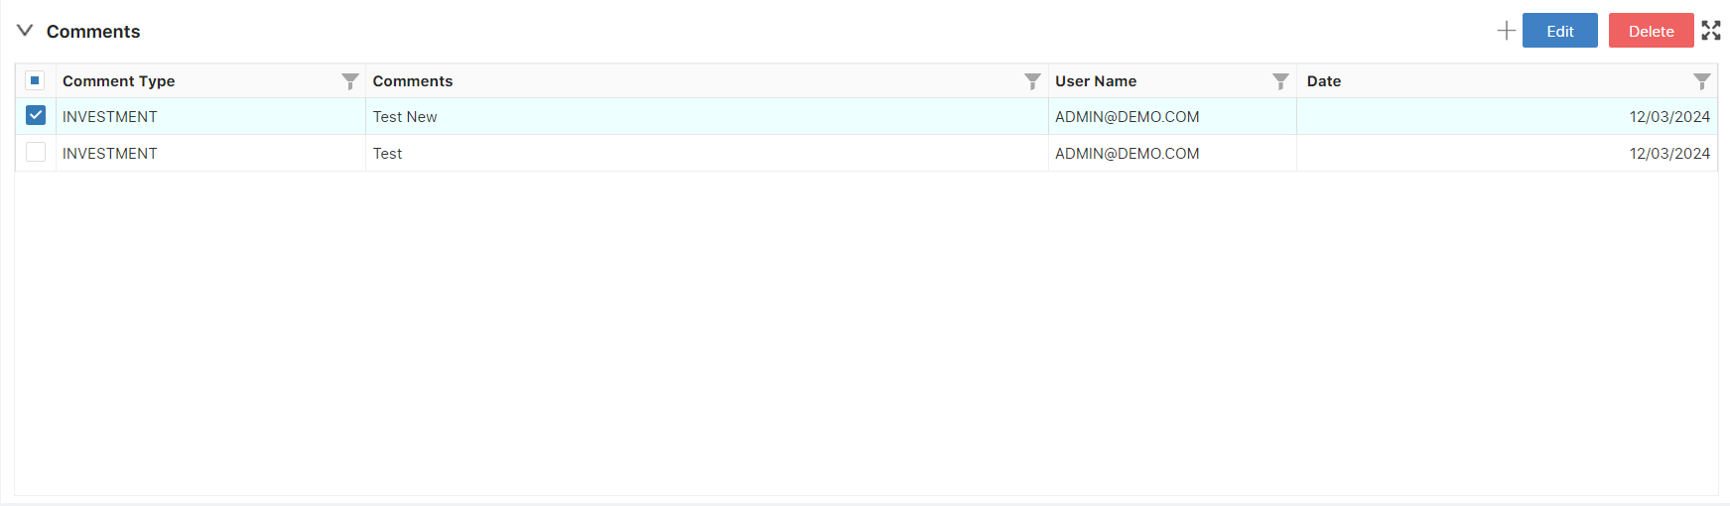

**Additional Development Added:** Added a new setting for check the expenditure and accural value.

